### Team Roles:

Project Owner: Likhitha Chowdary Paladugu

Scrum Master:

### Customer meeting:

We had a meeting scheduled with the client on zoom on 09/24/2020, in which we discussed the customer’s expectations and the deadlines for the same.

### Summary:

We created related accounts, and everyone studied the project to see details.

### User stories:

User Story 1: Multiple Profile Creation using the same Email ID

User Story 2: Email and Password Verification and Validation



### User interface:

Story 1 :mockup

This feature enables users to add multiple profiles using the same email id. This feature is requested by our client.

Story2: mockup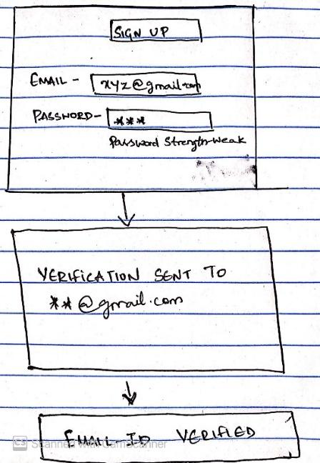

This feature allows the admin to check if the email id is registered and is valid. The user can create the account with FashioNxt only with a valid and verified email id. Also, this feature validates the password strength.

### Pivotal Tracker:

<https://www.pivotaltracker.com/n/projects/2468515>

### GitHub:

<https://github.com/mulkiye/match-my-fashion-public>